Paul Minniti
COSC 120
Lab #4
3-2-15

Lab report: I have finished all the tasks of the lab by my own. I have had no problem working out the questions. It took me approximately 1:30 hours/minutes to work on it.

Lab 4.1

Source code

// This program displays a hot beverage menu and prompts the user to
// make a selection. A switch statement determines which item the user
// has chosen. A do-while loop repeats until the user selects item E
// from the menu.

// Paul Minniti
#include <iostream>
#include <iomanip>
using namespace std;
int main()
{
int number;
float cost;
char beverage;
bool validBeverage;
cout << fixed << showpoint << setprecision(2);
do
{
cout << endl << endl;
cout << "Hot Beverage Menu" << endl << endl;
cout << "A: Coffee $1.00" << endl;
cout << "B: Tea $ .75" << endl;
cout << "C: Hot Chocolate $1.25" << endl;
cout << "D: Cappuccino $2.50" << endl << endl << endl;
cout << "Enter the beverage A,B,C, or D you desire" << endl;
cout << "Enter E to exit the program" << endl << endl;
cin >> beverage;
switch (beverage)
{
case 'a':
case 'A':
case 'b':
case 'B':
case 'c':
case 'C':
case 'd':
case 'D': validBeverage = true;
break;
default: validBeverage = false;
}
if (validBeverage == true)
{
cout << "How many cups would you like?" << endl;
cin >> number;
}
switch (beverage)
{
case 'a':
case 'A': cost = number * 1.0;
cout << "The total cost is $ " << cost << endl;
break;
case 'b':
case 'B': cost = number * 0.75;
case 'c':
case 'C': cost = number * 1.25;
case 'd':
case 'D': cost = number * 2.50;
case 'e':
case 'E': cout << " Please come again" << endl;
break;
default:cout << "I'm sorry, you have made an invalid selection" << endl;
cout << " Try again please" << endl;
}
} while (beverage == 'e');
return 0;

}

sample output

Ex.1

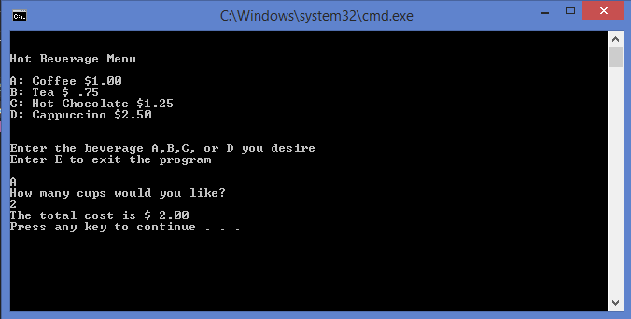

Ex.2
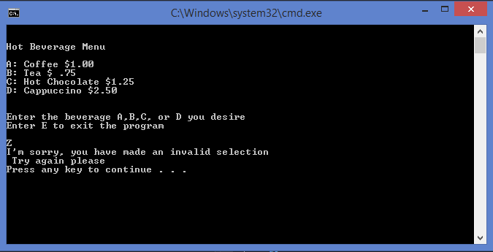

Ex.3

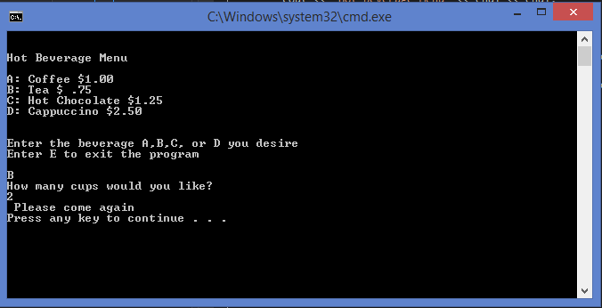

Lab 4.2

Exercise 1:

[Source code ]

……
[sample output]

…….

[answers for exercise]

……

Exercise 2:
……..

